Reference link :

<https://www.liquidweb.com/kb/install-java-8-on-centos-7/>

**1. update yum repository:**

*yum -y update*

**2. Install java 8**

yum install java-1.8.0-openjdk

**3. Verify Java is Installed**

java -version

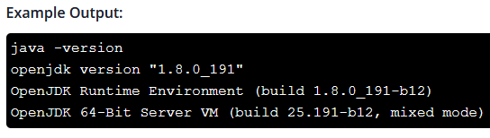

**4. Set Java’s Home Environment**

**4.1 Find Java’s Path**

update-alternatives --config java  
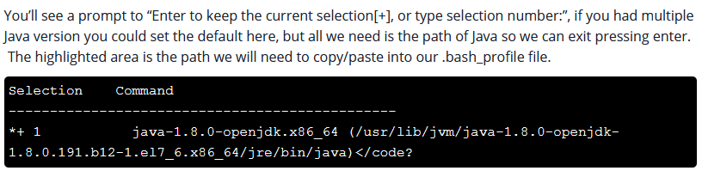

**4.2 Setting Java’s Path in Your Environment**

**vi ~/.bash_profile**

Export your Java path into the .bash_profile by adding the following to the bottom of the file. (Your path may look different from mine, and it’s not important that they vary.)

*export JAVA_HOME=/usr/lib/jvm/java-1.8.0-openjdk-1.8.0.191.b12-1.el7_6.x86_64/jre/bin/java*

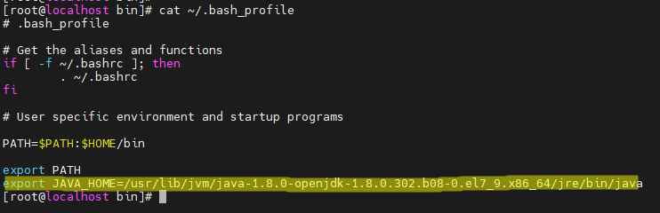

**4.3 Refresh the File:**

*source ~/.bash_profile*

**4.4 now be able to see the path you set.**

echo $JAVA_HOME

